November 2014

OPPORTUNITIES TO PROTECT DRINKING WATER SOURCES AND ADVANCE WATERSHED GOALS THROUGH THE CLEAN WATER ACT

A Toolkit for State, Interstate, Tribal and Federal Water Program Managers

The goal of this Toolkit is to show how state Clean Water Act (CWA) and Safe Drinking Water Act (SDWA) program staff and managers can more routinely and more intentionally coordinate CWA and SDWA activities to achieve improvements in the quality of our waters. This Toolkit:
- identifies opportunities to reduce pollution in drinking water sources by using CWA tools through key actions;
- provides examples of on-the-ground implementation to help readers understand how they can work across program lines and agency boundaries;
- demonstrates how program managers can align their efforts to protect source water through a combination of actions and institutional relationships that facilitate cross-program coordination at the national, regional, state, and watershed scales to achieve common objectives; and
- shows how state clean water programs can leverage the high value consumers place on public health and safe drinking water to increase public support for addressing surface and ground water quality challenges more effectively.

Each section of the Toolkit pertains to how specific CWA provisions and tools can be used to protect drinking water resources. The relationships between these provisions and examples of these tools are highlighted in the graphic below.
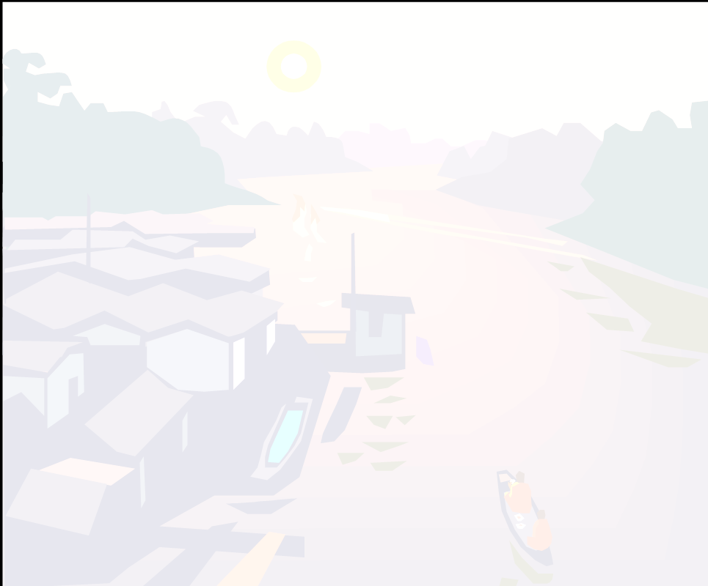
Monitoring, Assessment, & Impairment Listing
Water Quality Standards
Monitoring, Assessment, & Impairment Listing
Monitoring, Assessment, & Impairment Listing
Monitoring, Assessment, & Impairment Listing
Protecting source water with
· Designated uses for sources of drinking water
· Numeric and narrative water quality criteria
· Anti-degradation tools

Protecting source water with
· Assessment methodologies tailored to drinking water
· Data shared by drinking water stakeholders

Monitoring, Assessment, & Impairment Listing

Total Maximum Daily Loads

Protecting source water by
· Prioritizing TMDLs for impaired source waters
· Developing TMDLs in view of drinking water contaminants
· Supporting nonpoint source controls
· Identifying opportunities to protect waters that are not yet impaired

Point Sources
Nonpoint Sources

Protecting source water with
· NPDES permit effluent limits and other conditions
· Downstream notification
· Green infrastructure planning and stormwater management
Protecting source water by
· Setting priorities that include SWP in Watershed Plans
· Leveraging technical and financial resources across programs

